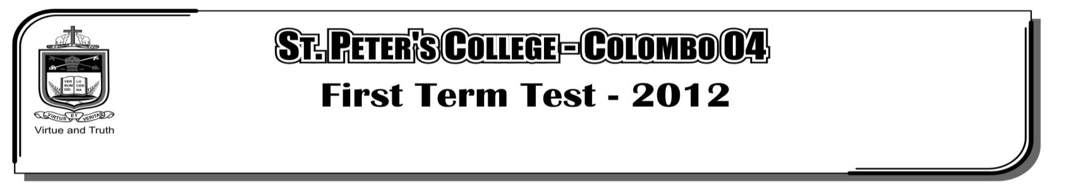

**THIRD TERM EXAMINATION - 2021**

**GRADE 11 – Western Music**

**02 Hours**

**Part - II**

**Answer question 01 which is compulsory and 4 others selecting two from each part A and B.**

01. Compulsory : questions are based on the following music ‘The happy Farmer’ from the album for the young.

Read it carefully and answer the questions based on it.

1. The melody of the music is in the left hand. Right hand plays the accompaniment to the melody. Write the melody (Bass) from bar 1 – bar 4 with the anacrusis, in the stave provided.

|  |
| --- |
|  |
|  |
|  |
|  |

2. Transpose the above melody one octave higher in the treble clef.

|  |
| --- |
|  |
|  |
|  |
|  |

3. How many times does the main melody appears in the piece……….

Explain it with bar numbers.

4. What would be the key of the given piece?

5. What is the relative key of the given piece?

6. Does the piece start on an upbeat or down beat?

7. Name 02 articulation marks that appear in the piece?

8. Write the chord indications of the bracketed chords marked A and B.

9. Underline the following instruments which could play the melody of the above piece.

Recorder , Double Bass , Trumpet

10. Name the cadence at the end.

11. Name the interval marked at ‘C’ bar 14

12. Write the enharmonic equivalent to the circled note at bar 6 **(12 Marks)**

**Section A**

02. Write the name of the composer and the type of work in front of the given compositions.

**(12 Marks)**

|  |  |  |
| --- | --- | --- |
| **Composition** | **Composer** | **Type of work** |
| 1. The gollywogs cakewalk  2. The magic flute  3. St. Mathews passion  4. Fedelio  5. Rhapsody in blue  6. Childrens corner suite  7. Messiah  8. Aida  9. Liebestraum  10. Rain drop prelude  11. Wedding march  12. Young persons guide to the  orchestra |  |  |

03. E flat major scale, descending without

(a). Keysignature but adding any necessary sharps or flat signs using the given rhythm.

**(03 Marks)**

|  |
| --- |
|  |
|  |
|  |
|  |

(b). One octave of the C sharp harmonic minor, ascending in minims, beginning and ending on the mediant, use the key signature mark semitones. **(03 Marks)**

|  |
| --- |
|  |
|  |
|  |
|  |

(c). Name the interval formed by each numbered pair of notes. **(04 Marks)**

|  |  |  |
| --- | --- | --- |
|  |  |  |
|  |  |  |
|  |  |  |
|  |  |  |

(d). Write the key signatures named below, followed by the tonic triads. **(02 Marks)**

|  |  |
| --- | --- |
|  |  |
|  |  |
|  |  |
|  |  |

F minor

D major

04. (a). Write the melodic minor scale of F sharp, ascending and descending with key signature, use F clef in crotchets. **(03 Marks)**

(b). Describe the following intervals. **(04 Marks)**

|  |  |  |  |
| --- | --- | --- | --- |
|  |  |  |  |
|  |  |  |  |
|  |  |  |  |
|  |  |  |  |

(c). Add the correct clef and accidentals to the following tonic triads. **(04 Marks)**

|  |  |  |  |
| --- | --- | --- | --- |
|  |  |  |  |
|  |  |  |  |
|  |  |  |  |
|  |  |  |  |

Major

Minor

Minor

Major

(d). Write the key signature of the given key. **(01 Mark)**

|  |
| --- |
|  |
|  |
|  |
|  |

C minor

**Section B**

05. (a). Write the following cadences in SATB style use dominant 7th in perfect cadence use key signature. **(2x3=6 Marks)**

Interrupted C minor

Perfect in F major

|  |  |  |
| --- | --- | --- |
|  |  |  |
|  |  |  |
|  |  |  |
|  |  |  |
|  |  |  |
|  |  |  |
|  |  |  |
|  |  |  |
|  |  |  |

Imperfect A major

(b). Answer the following questions. **(1x6=6 Marks)**

1. Name two keyboard instruments other than Piano and Harpsichord.

i. ii.

2. Name two degrees named as ‘Achala Swara’ in oriental music.

i. ii.

3. Name two Indian percussion instruments.

i. ii.

06. Describe the chords indicated by numbers.

(a). Key is E flat major. **(03 Marks)**

|  |  |  |
| --- | --- | --- |
|  |  |  |
|  |  |  |
|  |  |  |
|  |  |  |
|  |  |  |
|  |  |  |
|  |  |  |
|  |  |  |
|  |  |  |

3

2

1

(b). Write the above music in open score with suitable clefs. **(03 Marks)**

|  |
| --- |
|  |
|  |
|  |
|  |

|  |
| --- |
|  |
|  |
|  |
|  |

|  |
| --- |
|  |
|  |
|  |
|  |

|  |
| --- |
|  |
|  |
|  |
|  |

(c). Name four periods in history of western music. **(02 Marks)**

i. ii.

iii. iv.

(d). Briefly describe one of them with examples of composers, works instruments used.

**(04 Marks)**

07. (a). Name two instruments used in Jazz 1. _____________ 2. _____________

(b). Name the transposing interval of English horn and French horn _____________

(c). Which instruments are named as following.

* Cindrella of the orchestra _____________

* Clown of the orchestra _____________

(d). Name an instrument which could play a Glissando _____________

(e). Name 02 ritulas or Shanthi Karma belonging to dance forms in Sri Lanka.

i. ii.

**(08 Marks)**

(f). Describe the following forms. **(04 Marks)**

i. Rondo form – give examples.

ii. Air with variation form – given examples.

